Pokhara University

Level: Bachelor | Semester – Spring | Year : 2006
Programme: BE |  | Full Marks: 100
Course: Electronic Devices |  | Time : 3hrs.

Candidates are required to give their answers in their own words as far as practicable.
The figures in the margin indicate full marks.

Attempt all the questions.

 | - What is model? Draw different models of diode when it is forward biased and reverse biased.  - "Diode is a non-linear device" Do you agree? Justify your answer.  - Why is an intrinsic semiconductor not adequate for making semiconductor devices? What will you do to make it useful for making semiconductor devices? Draw the energy band diagram of n-type and p-type semiconductor and explain in brief. | 5  5  1+1+3
 | - Zener diode is said to be the backbone of voltage stabilizer. Justify your answer.  - A Zener regulator has 12 V Zener voltage with variable load resistance. Calculate:  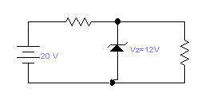  Rs=100Ω  R_{L}=200Ω to 1kΩ  c) Explain transition region capacitance and diffusion capacitance in brief. | 5  5  5
 | - What do you mean by the input and output characteristics of a transistor? Draw output characteristics curve of CE configuration and show the regions of operations.  - The potential divider circuit shown in figure has the values as follows: I_{E} = 2 mA, I_{B} = 50 μA, V_{BE} = 0.3 V, R_{E} = 1 KΩ, R₂= 10 KΩ and V_{CC} = 10V. Find the value of R₁ if the transistor is operating in the active region.  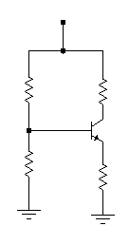  V_{CC}=20V  Rc  Ic  R₁= ?  I₁  I₂  R_{2=10kΩ}  R_{E=1kΩ}  I_{E}  I_{B} = 50μA | 8  7
 | - What is the basic difference between linear and non-linear circuit? Explain piecewise linear modelling for the non-linear circuit analysis.  - For the circuit given below, find out the value of voltage gain and output impedance.  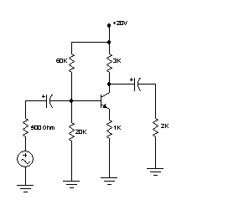 | 8  7
 | - What is the primary difference between the construction of depletion – type and enhancement – type MOSFETs.  - For the n-channel JFET shown in the figure below. Determine the :  - Gate to source voltage (V_{GS})  - Drain current (I_{D})  - Drain to source voltage (V_{DS})  Given: IDSS = 10 mA and V_{p} = -8 V  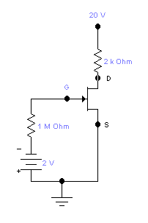  c) Draw and explain the high frequency T-model of CB configuration. | 5  5  5
 | - For the circuits given below, find out the output voltage waveforms. Briefly explain now the waveforms are drawn. (Assume ideal diode).  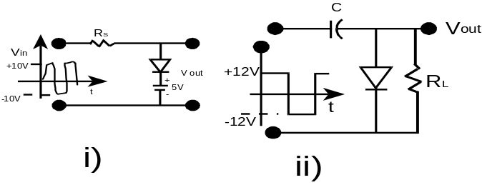  - Why rectification is necessary? In rectification process normally we use step down transformer, why? Draw full wave bridge rectifier circuit and explain its operation. | 8  7
 | Write short notes on (Any Two):  - Thermal instability  - Varactor diode and its applications  - Uni-junction Transistor (UJT) | 5×2

